- Output of the Commands:
- make TARGET=linux64 build

2. make TARGET=linux64 XCMD='-c4' certify-all
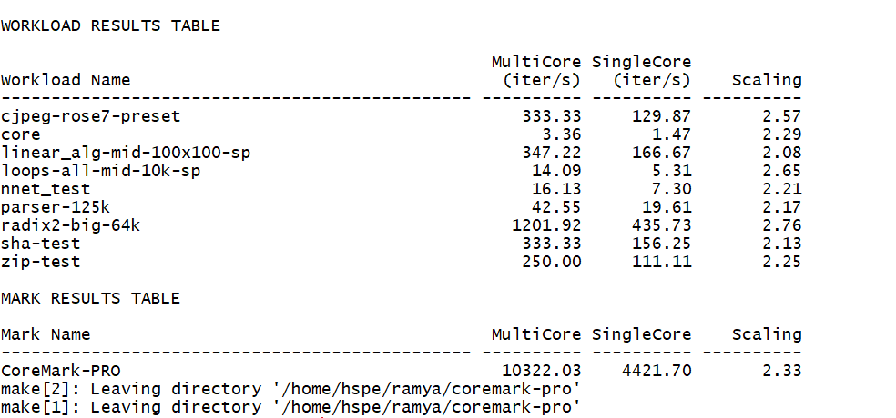

- Output for the commands to check memory usage:
- Size
- Valgrind
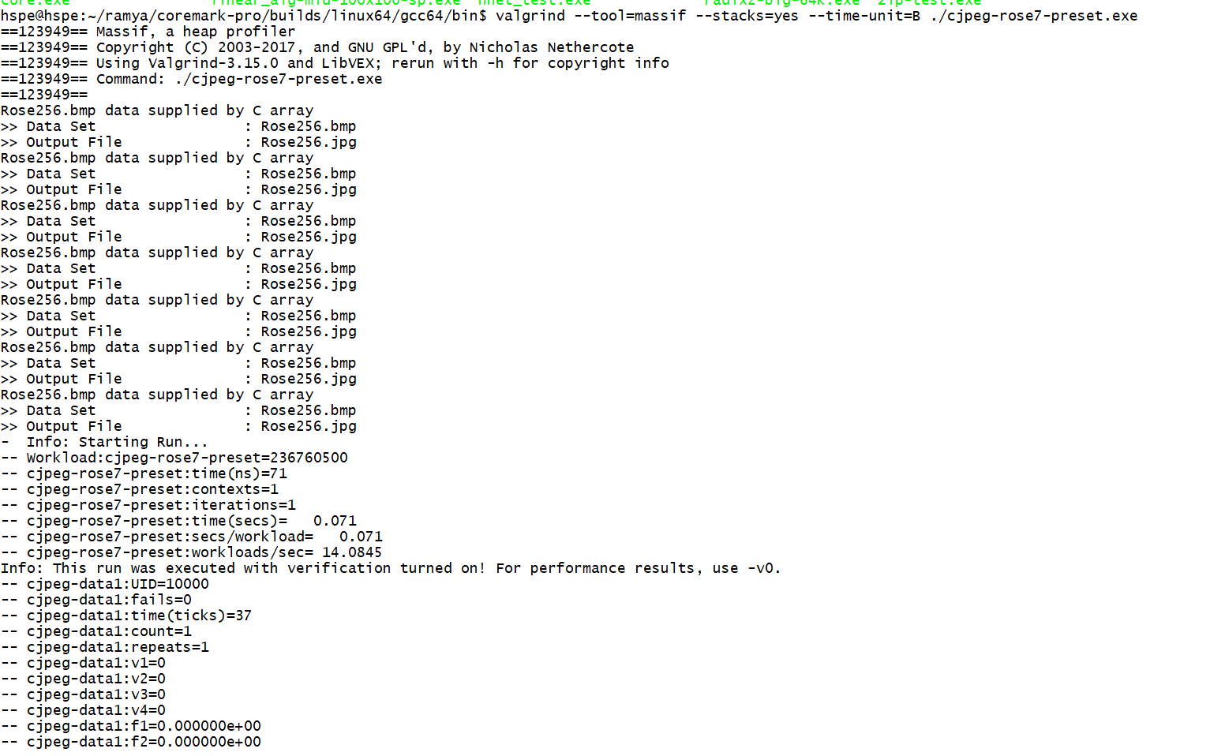
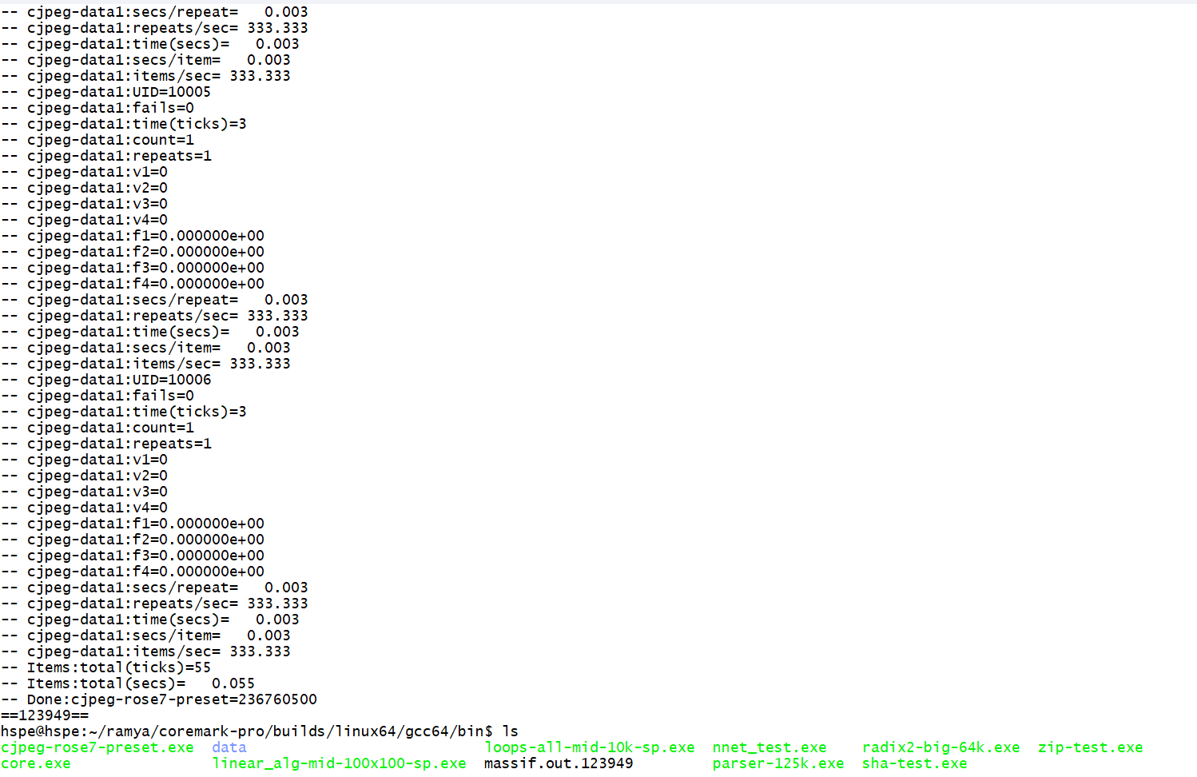
This command will create massif.out.123949 file. We can use ms_print massif.out.123949 command to analyse memory usage of a program in detail.

- Change the number of iterations.
Changed the number of iterations in workloads/workloadname/Workloadname*.opt files by adding -i(number of iterations)
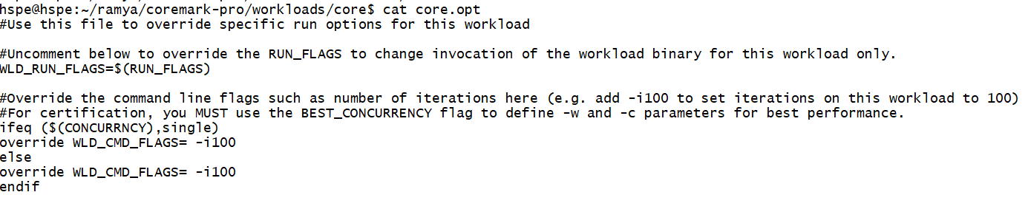
The workload results after changing the number of iterations to 100:

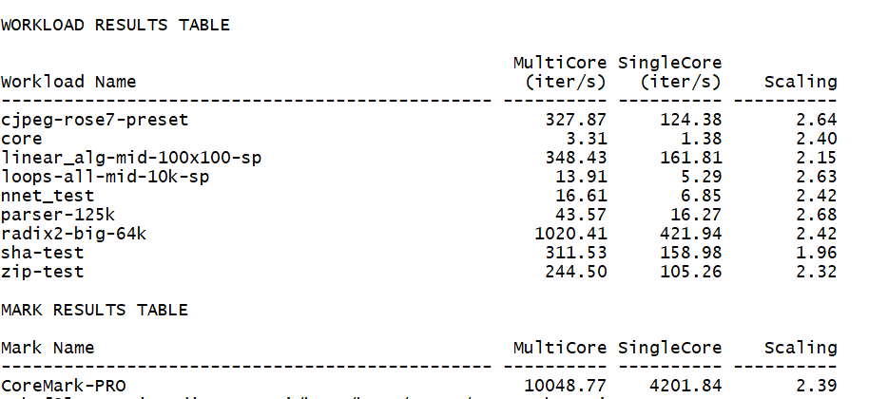

d) Questions discussed in meeting:

- How many cores are there in x86 processor?
- How many cores are being used by CoreMark-Pro for multicore?
- Coremark pro is running in user space or kernel space?
- what are those workloads? if it runs how many machine instructions it executes like that for all 9 workloads?
- what is the minimum and maximum value of scale in CoreMark-pro?

